import numpy as np

import os

class Q1:

def calculator(self,num1, num2 , option):

switcher = {

1: num1 + num2,

2: num1 - num2,

3: num1 * num2,

4: num1 / num2,

}

return switcher.get(option,"invalid option")

def main(self):

num1 = int(input("Enter number 1 "))

num2 = int(input("Enter number 2 "))

print("Enter 1 for addition")

print("Enter 2 for subtraction")

print("Enter 3 for multiplication")

print("Enter 4 for division")

option = int(input("Enter option"))

print(self.calculator(num1,num2,option))

class Q2:

def main(self):

with open("input2.txt" , "r") as file1:

data = file1.read()

data_1 = data[::-1]

file2 = open("output2.txt" , "w")

file2.write(data_1)

file2.close()

file2 = open("output2.txt" , "r")

print(file2.read())

class Q3:

def binary_search(self,array , key):

if len(array) <= 0:

return -1

low = 0

high = len(array) - 1

mid = (low + high)/2

mid = int(mid)

# print("DEBUG: mid", mid , "array[mid]" , array[mid])

if key == array[mid]:

return mid + 1

elif key < array[mid]:

answer = self.binary_search(array[:mid] , key)

if answer == -1:

return -1

else:

return answer

else:

answer = self.binary_search(array[mid+1:] , key)

if answer == -1:

return -1

else:

return mid + answer

def main(self):

array = [int(x) for x in input("Enter the elements with spacing: ").split()]

key = int(input("Enter the key: "))

array.sort()

print("The sorted array is: " , array)

print("Result at index: " , self.binary_search(array,key))

class Q4:

def main(self):

word_list = [str(word) for word in input("Enter the word list ").split()]

print(word_list)

word_list.sort()

print(word_list)

if __name__ == "__main__":

q1 = Q1()

q2 = Q2()

q3 = Q3()

q4 = Q4()

q1.main()

print("------------------------")

q2.main()

print("------------------------")

q3.main()

print("------------------------")

q4.main()

print("------------------------")

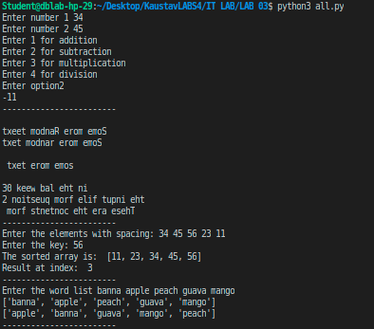

Q2 file reversing

